**Case Study: Pandas in Data Science**

*Harshwardhan Y. Zalte*

**Introduction:**

In today's data-driven world, the exponential growth of data across various sectors—such as finance, healthcare, e-commerce, and public services—has made data analysis an indispensable skill. Raw data is often unstructured, incomplete, or messy, which makes deriving actionable insights a major challenge. This is where data wrangling becomes essential. Data wrangling, or data cleaning, involves transforming raw data into a usable format, and without the right tools, this process can be tedious and error-prone.

Python, being a high-level, general-purpose programming language, has gained massive popularity in the data science ecosystem due to its simplicity, readability, and the richness of its libraries. One such powerful and essential library is Pandas—a cornerstone tool for data manipulation and analysis in Python. Originally developed by Wes McKinney in 2008, Pandas was designed to simplify data manipulation tasks such as cleaning, merging, reshaping, and aggregating data. Built on top of NumPy, it integrates seamlessly with other libraries such as Matplotlib, Seaborn, and Scikit-learn, making it ideal for tasks ranging from exploratory data analysis (EDA) to machine learning.

At the core of Pandas are two versatile data structures:

* Series: A one-dimensional labeled array, ideal for handling a single column of data.
* DataFrame: A two-dimensional, tabular structure resembling an Excel spreadsheet or SQL table, where each row represents a record and each column a variable.

With these structures, Pandas simplifies a wide range of operations:

* Importing/exporting data from formats like CSV, Excel, JSON, and SQL.
* Handling missing values through filling, interpolation, or deletion.
* Filtering, selecting, and transforming data using powerful indexing.
* Grouping and aggregating data to extract summary statistics.
* Reshaping and pivoting data for analysis.
* Visualizing data trends and patterns through built-in plotting functions.

Pandas has transformed how data is handled across industries. In finance, it is used for stock trend analysis and risk modeling. In healthcare, it helps process patient records and clinical trial data. E-commerce companies analyze customer behavior and optimize marketing using Pandas, while public health analysts use it to track and visualize disease outbreaks. Its ability to work efficiently with large datasets and perform complex operations with minimal code makes Pandas a favorite among data professionals.

This case study explores how Pandas enhances data manipulation, analysis, and decision-making in real-world scenarios. By applying it to a practical dataset—daily fitness activity records containing attributes like workout duration, pulse rate, and calories burned—we will demonstrate core Pandas functionalities such as data loading, cleaning, transformation, and aggregation. The study will also compare Pandas to traditional tools like Excel or SQL, emphasizing its advantages in scalability and efficiency. Furthermore, we will integrate Pandas with visualization libraries like Matplotlib and Seaborn to generate insightful graphics, address performance bottlenecks with large datasets, and explore optimization techniques and alternatives like Dask and Polars.

**Objective of Case Study:**

The primary objective of this case study on Pandas in Data Science is to explore how the Pandas library enhances data manipulation, analysis, and decision-making in practical scenarios. By focusing on its core functionalities—such as data loading, cleaning, transformation, and aggregation—the study aims to demonstrate how Pandas simplifies these essential tasks, making it an indispensable tool for data professionals. Using a real-world dataset, the case study will illustrate how Pandas supports exploratory data analysis (EDA) and helps uncover meaningful patterns and insights that inform better decision-making.

Additionally, the study will evaluate Pandas’ efficiency compared to traditional tools like Excel and SQL, highlighting its strengths in handling structured data. It will also emphasize Pandas’ seamless integration with visualization libraries such as Matplotlib and Seaborn to create insightful visual representations. Common challenges, such as performance limitations with large datasets, will be addressed, along with potential solutions like optimization techniques and alternative libraries such as Dask and Polars. Through this comprehensive exploration, the case study aims to reinforce best practices in Pandas usage—promoting efficient coding, memory management, and clean, readable code—while showcasing the library’s central role in modern data science workflows.

**Dataset Description:**

A dataset is a structured collection of data that is commonly used in fields such as data science, machine learning, statistics, and research to draw insights, perform analysis, and support decision-making. It typically resembles a table, where rows represent individual records or observations, and columns represent specific attributes or variables related to those records. Datasets can vary in size and complexity—from small, manually created tables to massive, multi-dimensional data collected from sensors, websites, or real-time systems. They can be stored in a variety of formats, including CSV (Comma-Separated Values), Excel, JSON, SQL databases, or even cloud-based storage systems.

In the context of data science, a dataset is the foundational input used for analysing, visualizing, and building models. For example, a dataset may contain information about customers, sales, medical records, or in this case study—fitness activity. Datasets can be small and simple or large and complex, depending on the use case.

For this case study we will using the following dataset:

|  |  |  |  |
| --- | --- | --- | --- |
| **Column Name** | **Description** | **Datatype** | **Example Value** |
| **Duration** | Duration of Workout (min) | Integer | 60 |
| **Date** | Date of the workout | String/ Date | 2020/12/01 |
| **Pulse** | Average heart rate during workout | Integer | 110 |
| **Maxpulse** | Maximum heart rate recorded | Integer | 130 |
| **Calories** | Calories burned during workout | Float (nullable) | 409.1 |

Source: [Pandas Practice Dataset](https://www.kaggle.com/datasets/themrityunjaypathak/pandas-practice-dataset) (Kaggle)

For example, records data related to daily fitness activities. Each row represents a workout session, and the columns capture different aspects of that session such as the duration of exercise (Duration), the date it occurred (Date), the average and maximum pulse during the session (Pulse and Maxpulse), and the number of calories burned (Calories). This dataset is particularly useful for case studies in Pandas, a powerful Python library for data analysis, because it includes a mix of numeric data, date values, and missing entries. These elements create opportunities to demonstrate real-world data handling techniques such as type conversion (e.g., converting string dates to datetime objects), dealing with null or missing values, performing aggregations and filtering, and generating statistical summaries.

**Implementation:**

**1. Loading Data**

**Loading Data** is the foundational step where raw data is imported into a pandas DataFrame for analysis. In data science, this typically involves reading structured files like CSVs, Excel spreadsheets, or database queries using functions like pd.read_csv() or pd.read_sql(). Proper loading ensures the data is correctly parsed—dates are converted to datetime objects, missing values are identified, and columns are assigned appropriate data types. This step directly impacts all subsequent analyses, as errors here (like incorrect delimiters or character encodings) can corrupt the entire workflow. For time-series data, critical parameters like parse_dates and dtype specifications help maintain data integrity from the outset.



**2. Data Exploration**

**Data Exploration** follows loading, where analysts investigate the dataset’s structure and quality. Using methods like df.head() to preview rows, df.describe() to summarize statistics, and df.info() to check data types, this phase reveals patterns, outliers, and potential issues. Exploration answers key questions: How many missing values exist? Are there unexpected duplicates? What’s the distribution of numerical features? In data science, this step guides decisions about cleaning and transformation—for example, skewed distributions may require log transformations, or high missing-value counts might necessitate imputation strategies. Visualization tools like histograms or boxplots often complement these tabular inspections.



Output:





Output:





Output:



**3. Data Cleaning**

Data Cleaning addresses inconsistencies uncovered during exploration. Real-world data is often messy—containing missing values, duplicates, or illogical entries (like a pulse rate exceeding the max pulse). Pandas provides tools like df.dropna() to remove gaps, df.fillna() to impute reasonable values (e.g., using medians), and df.replace() to correct typos. For datetime or categorical data, cleaning might involve standardizing formats (e.g., converting "Jan-2023" and "01/2023" to a uniform date). This step is crucial because models and visualizations built on dirty data yield unreliable results. A common example is fixing swapped values between columns (like pulse and max pulse) using conditional logic with df.loc[].

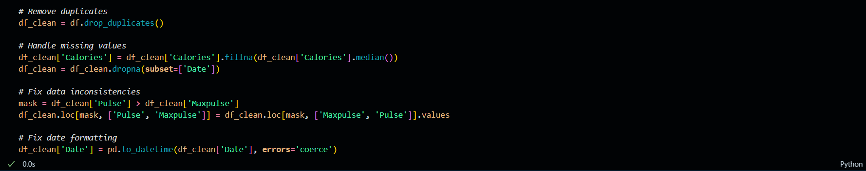

* drop_duplicates(): Removes duplicate rows
* fillna(): Fills missing values (using median here)
* dropna(): Removes rows with missing values in specified columns
* pd.to_datetime(): Ensures consistent date format
* loc[]: Label-based indexing for conditional fixes

**4. Data Selection**

**Data Selection** narrows the dataset to relevant subsets. Analysts might filter rows (e.g., df[df['Calories'] > 300] to study high-intensity workouts) or select specific columns (e.g., df[['Date', 'Duration']] for time-and-effort analysis). Advanced selection includes label-based (df.loc[]) or position-based (df.iloc[]) indexing. In data science, selection improves computational efficiency and focuses analysis on meaningful variables—for instance, excluding irrelevant columns before model training. Time-based selection (like df[df['Date'].dt.year == 2020]) is particularly valuable for temporal analyses.

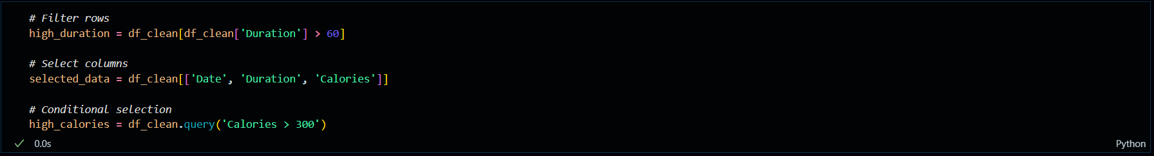

* Boolean indexing (df[df['col'] > value]): Filters rows by condition
* query(): SQL-like filtering syntax
* Column selection: df[['col1', 'col2']]

**5. Data Sorting**

Data Sorting reorders records to reveal trends or rank observations. The df.sort_values() method organizes data by one or more columns (e.g., sorting workouts by date and descending calories). Sorting is essential for time-series analysis to ensure chronological order, or for identifying top/bottom records (like highest-calorie workouts). It also prepares data for operations like grouping or merging, where aligned indices improve performance. A typical use case is sorting customer transactions by purchase date before analyzing buying patterns over time.



* sort_values(): Sorts DataFrame by column values
* ascending: Controls sort direction (True=ascending)
* Accepts list for multi-column sorting

**6. Data Grouping**

Data Grouping segments data into categories for aggregated analysis. Using df.groupby(), analysts split data by a key (e.g., "Duration") and compute statistics (mean, sum) for each group. This reveals insights like average calories burned per workout length or total sales per product category. Combined with pd.Grouper, it supports time-based aggregation (e.g., weekly summaries). Grouping underpins feature engineering—creating new variables from group statistics (e.g., "calories vs. group mean"). In machine learning, grouped aggregates often become inputs for models.

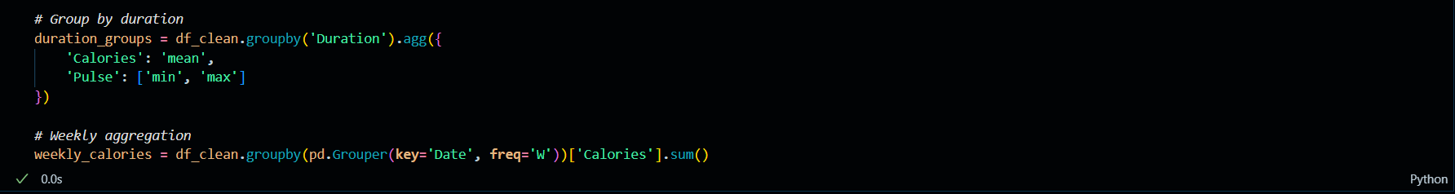

* groupby(): Groups data by specified column
* agg(): Performs multiple aggregations
* pd.Grouper(): Time-based grouping (weekly here)
* sum()/mean(): Aggregation functions

**7. Data Visualization**

Data Visualization translates tabular data into graphical representations for intuitive understanding. Pandas integrates with Matplotlib and Seaborn to generate plots directly from DataFrames. Line charts (df.plot.line()) show trends over time, histograms reveal distributions, and scatter plots expose relationships between variables (e.g., pulse vs. calories). Effective visualizations highlight outliers, clusters, or correlations that might be missed in tables. For data science, this step is vital for exploratory analysis (identifying patterns) and communication (presenting findings to stakeholders). Customization—like adding titles (plt.title()) or adjusting axes—enhances clarity.



Output:

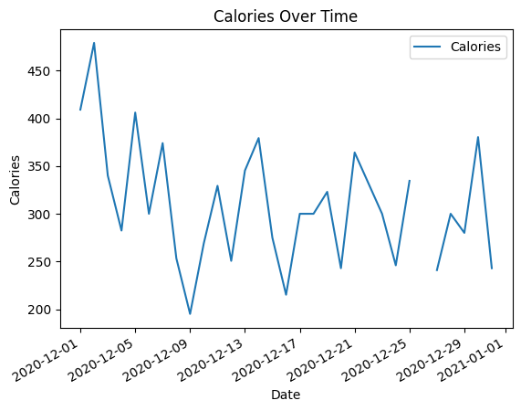



Output:

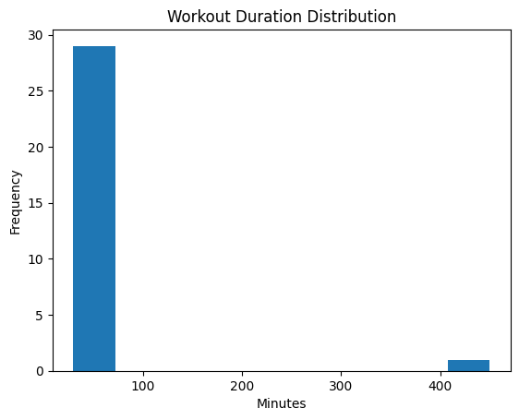

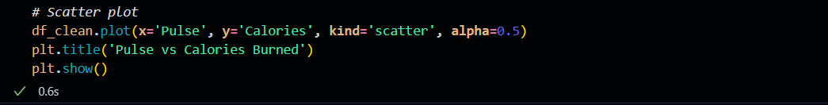

Output:

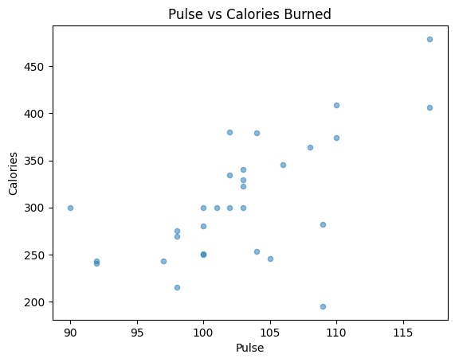

These operations form an iterative pipeline. Loading brings data into the environment, exploration identifies issues, cleaning rectifies them, and selection/sorting refine the dataset. Grouping and visualization then extract and communicate insights. For example, a cleaned and sorted dataset allows accurate grouping by time periods, which can be visualized to show seasonal trends. Mastering this workflow enables data scientists to transform raw data into actionable knowledge efficiently.

**Example:**

**COVID-19 Data Visualization**

During the COVID-19 pandemic, accurate and up-to-date data was crucial for managing public health responses. Public health analysts used Pandas to work with daily case counts, death tolls, and vaccination data provided by global organizations like WHO and Johns Hopkins University. With Pandas, they:

1) Aggregate data by country and region using groupby() and sum() to track global and local trends.

2) Normalize case counts to per-capita rates, making comparisons between regions more meaningful.

3) Create new columns for growth rates and rolling averages to identify upward or downward trends.

4) Visualize trends in infection rates and vaccination progress using Matplotlib and Seaborn.

These analyses were essential in identifying hotspots, predicting case surges, and making data-backed decisions regarding lockdowns, vaccine distribution, and healthcare resource allocation. Pandas made it possible to automate these updates daily, ensuring that decision makers always had access to current information.  
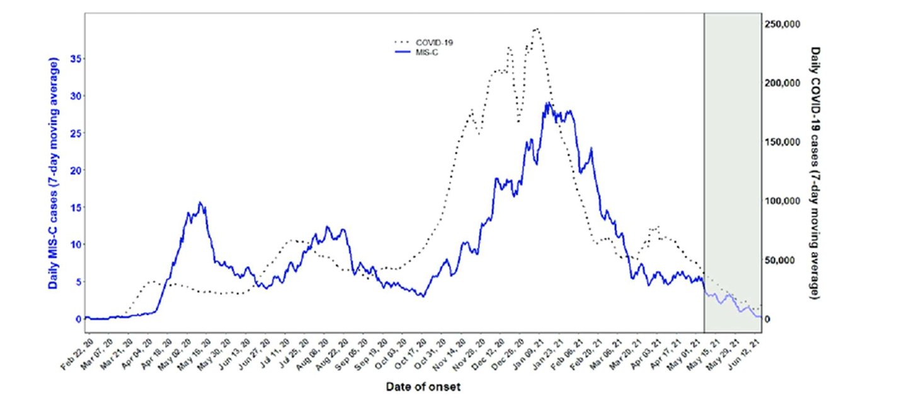

**Analysis / Discussion**

Analyzing the examples above, we observe several commonalities in how Pandas empowers users across different sectors:

1) Efficient Data Cleaning: Raw datasets often contain inconsistencies, which Pandas resolves quickly and effectively using intuitive syntax.

2) Exploratory Data Analysis (EDA): With simple methods like .describe(), .info(), .value_counts(), and visualization support, users can explore data distributions, detect outliers, and identify correlations.

3) Data Transformation and Aggregation: Functions such as groupby(), pivot_table(), stack(), unstack(), and apply() enable deep data transformations with minimal code, enhancing both speed and clarity of analysis.

**Challenges Addressed:**

1) High dimensionality and complexity of datasets from multiple sources.

2) Need for reproducible, modular, and readable code in professional environments.

3) Integration with visualization tools for effective storytelling and communication of results.

**Insights Gained:**

1) Pandas enables fast prototyping and seamless data manipulation, crucial for iterative workflows.

2) It enhances productivity and reduces the barrier to entry for aspiring data scientists and analysts.

3) Supports scalable workflows when combined with libraries like Dask for big data processing.

4) Encourages data literacy across domains by simplifying access to robust data analysis tools.

**Conclusion:**

Pandas has emerged as a cornerstone in the field of data science, particularly within the Python ecosystem. Whether it's analyzing stock market trends or tracking the spread of global pandemics, Pandas proves invaluable due to its extensive functionality. Its intuitive syntax, robust features, and compatibility with key Python libraries such as NumPy, Matplotlib, and Scikit-learn make it accessible for both beginners and seasoned data professionals.

As the scale and complexity of data continue to increase, the need for efficient tools that can manage, process, and extract meaningful insights becomes even more pressing. Pandas distinguishes itself not only as a tool for data manipulation but also as a driving force for data-centric innovation. Being open-source and actively supported by a vibrant community, it constantly evolves to meet the dynamic needs of the data science industry.

In summary, mastering Pandas has become a necessity for anyone working with data. Whether in academic research, commercial enterprises, or public sector initiatives, Pandas empowers users to unlock the true potential of data and make impactful, data-driven decisions.

**References:**

<https://www.w3schools.com/python/pandas/default.asp>

<https://www.youtube.com/watch?v=mkYBJwX_dMs&t=729s&pp=ygUGcGFuZGFz>

<https://www.kaggle.com/datasets/themrityunjaypathak/pandas-practice-dataset>

<https://github.com/CSSEGISandData/COVID-19>

Pandas Documentation: <https://pandas.pydata.org/docs>

Find Dataset and Notebook: <https://github.com/HarshwardhanZalte/Pandas-Case-Study>